ICARUS trigger efficiency analysis

Tanvi Krishnan, SULI Intern Summer 2022

Mentor: Gianluca Petrillo

Neutrinos are elusive elementary particles with many interesting properties we would like to better understand. To do so, we use neutrino detectors like ICARUS. The detector employs a trigger system to filter the massive amounts of data collected daily, keeping only our desired events for further analysis. My work centers around analyzing the efficiency of the trigger system. The trigger works by setting a minimum requirement of light to cause an event to be recorded. I use a software emulation of the trigger hardware to analyze the efficiency of different light requirement levels in filtering out background from datasets of cathode-crossing particle tracks. We specifically used cathode-crossing tracks as those are the tracks for which we can reconstruct the track time, which is necessary for the trigger emulation. This data was collected without the hardware trigger system employed, creating a minimum bias dataset, without bias from the hardware trigger in filtering the data. I have analyzed the efficiency of the trigger system as a function of different track characteristics and uncovered the 2m track anomaly, which is that roughly 2m long tracks are less efficient at triggering.

1. INTRODUCTION

Neutrinos are nearly massless, neutrally charged elementary particles formed as a byproduct of nuclear reactions. They are extremely difficult to detect directly but we can use specially designed neutrino detectors like ICARUS to capture snapshots of their interactions with other matter particles. Neutrinos have many potential applications, including in nuclear weapons safety and supernova research. Before we can use neutrinos in these ways, we first need to better understand their properties, and that’s why we need detectors like ICARUS to help us learn more.

(a)

(b)

Figure 1. Neutrino events in the ICARUS detector. (a) Electron neutrino entering detector from the left, interacting to turn into an electron and a secondary particle. (b) Muon neutrino entering detector from the top left, interacting to turn into a muon (long track) and secondary particle (short track). Image credits: ICARUS collaboration

1. BACKGROUND

ICARUS (Imaging Cosmic and Rare Underground Signals) is a Liquid Argon Time Projection Chamber (LArTPC) detector. It creates digital images of neutrino interactions to better understand their properties. It serves as the far detector of the Short Baseline Neutrino Program at Fermilab, and is located 600 m from the target, where the neutrinos are produced.

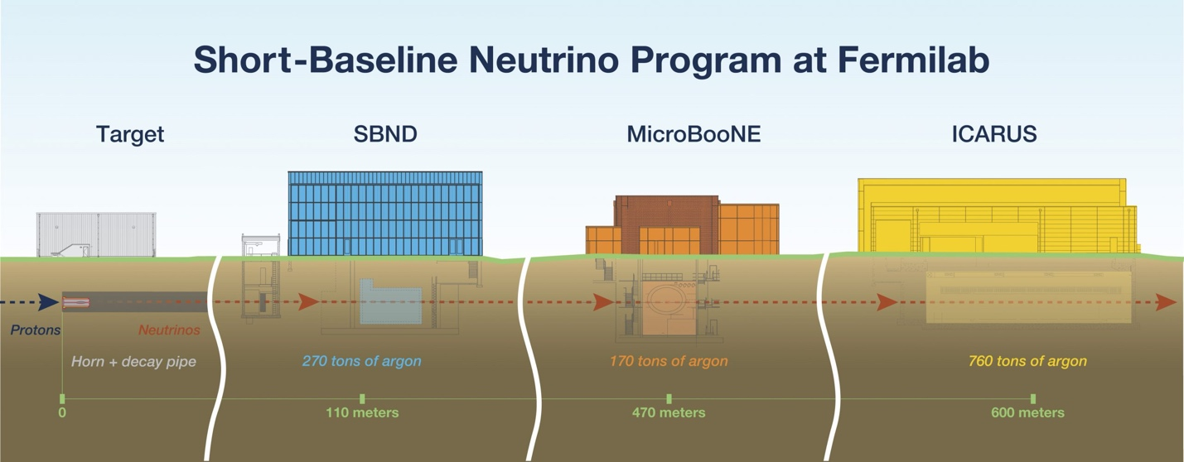Figure 2. Overview of SBN at Fermilab. Image credits: ICARUS collaboration

The detector itself is composed of two semi-independent cryostats, labeled East and West. Each of these cryostats contains two Liquid Argon Time Projection Chambers (LArTPCs), also labeled East or West. There are two types of information collected by each LArTPC: charge and light. A schematic of how a LArTPC collects data is shown in Figure 3. A neutrino passing through the detector might interact and form secondary particles, which in turn interact with the Argon atoms they pass, causing them to emit scintillation light or kick out electrons. Each LArTPC functions like a large capacitor, where the electrons deposited in the chamber drift toward the anode at a constant drift velocity. When they reach the anode, the electrons create induction signals in the wire planes. Using reconstruction methods, we can then reconstruct the particle’s track in the detector. This drift of electrons takes around 1.6 milliseconds. The PMTs (photomultipliers) detect the scintillation light produced by the track as well. This light is recorded on the order of nanoseconds after an event occurs, much faster than the drift time. In the time it takes the electrons from a neutrino event to drift to the anode, on average about 20 cosmic rays may pass through the detector as well. We refer to these cosmic rays as background, as they are not the interactions we are looking to study. Since the light travels much faster, we can use the PMT data to distinguish the background produced by cosmic rays from the neutrino events we are looking to study.

Cathode

Secondary

Particles

Neutrino

Anode

PMTs

Wire Planes

e- drift

e-

scintillation light

Figure 3. Schematic of a Liquid Argon Time Projection Chamber (LArTPC) in ICARUS.

The trigger is a hardware system in the detector that filters out background from cosmic rays and other particles in real time. We emulate its performance using software to test different light sensitivity levels for the trigger. Each light sensitivity level dictates a certain number of PMT pairs that must exceed a minimum threshold of light to cause us to record an event. A schematic depiction of the trigger logic is shown in Figure 4. The light sensitivity levels we tested are M1 (1 PMT pair exceeds threshold within entire detector) and S3, S5, S8, S10, and S15 (3-15 PMT pairs exceed threshold within one of 3 6m-long sections of the detector along the z-axis). We hope to select the sensitivity level to maximize efficiency of recording our desired tracks while minimizing background accumulated. The S5 level is what’s currently employed in the detector, based on prior analysis. To do this, we analyze how the different levels perform across different regions of the parameter space of our sample tracks.

Figure 4. ICARUS Trigger System Logic.

Light > Sensitivity

Ignore

Record

True

False

The data comes from a “minimum bias” run, which means that the data was collected without the hardware trigger constraints. We used software to emulated trigger performance for our sample of tracks under different light sensitivity levels. We only analyzed cathode-crossing tracks in this sample, as those are the only tracks for which we are currently able to reconstruct track time without biasing our trigger efficiency measurement. In the future we hope to be able to analyze non-cathode crossing tracks by matching tracks in the TPCs to “hits” on the CRT (Cosmic Ray Tagger). The CRT is a set of sensors on the outside of the detector that record hits of particles entering and leaving the TPCs. The matching of this data is currently underway, and we hope this method will allow us to analyze a less biased sample.

1. EFFICIENCY ANALYSIS

The formula we used for calculating efficiency is given by Eqn. (1).

$\text{Efficiency = }\frac{\text{selected tracks that would trigger}}{\text{selected tracks}}$ (1)

We first looked at efficiency as a function of track length in both cryostats. Efficiency is higher for longer tracks, as shown in Figure 5. This makes physical sense, as longer tracks generally have more energy and generate more light as they pass through the detector. This makes them more likely to be detected by the trigger, regardless of light sensitivity level. Figure 5 shows the plot for the East cryostat, but the same trend is seen in the West cryostat.

Figure 5. Efficiency as a function of track length in the East cryostat for different light sensitivity levels. Vertical error bars show a 68% Confidence Interval using an exact Clopper-Pearson interval, while horizontal error bars depict the size of the bins.

1. THE 2M TRACK ANOMALY

When looking closer at Figure 5, specifically at tracks around 2m in length, there is a noticeable drop in efficiency. This is what we refer to as the 2m track anomaly. This feature is especially evident in the East cryostat (Figure 6) but is also present to a lesser extent in the West cryostat. There is no noticeable spatial pattern within the detector for these 2m tracks that fail to trigger. This feature is especially troubling, as there must be some reason why not even a single PMT sees enough light (roughly 10 photons) to exceed the threshold and trigger for the M1 light sensitivity level, which is especially unusual and unexpected. However, statistics are extremely limited for the dataset currently used in this analysis. We are hopeful that a newer run may be able to provide more insight on this issue.

Figure 6. Efficiency of Trigger as a function of Track length in the East cryostat for tracks 150-300 cm in length. Vertical error bars show a 68% Confidence Interval using an exact Clopper-Pearson interval, while horizontal error bars depict the size of the bins.

One possible solution we explored was shifting the trigger emulation window. In the trigger emulation software, for a given track occurring at time t0, light seen by the PMTs in a 20µs window before t0 is checked against the different light sensitivity levels to determine triggering. Looking at the raw PMT data, many of the ~2m tracks that failed to trigger was paired with light detected by the PMTs <5µs after t0 that would be missed by the trigger. We shifted the window back by 5 µs to see whether the overall trigger efficiency improved.

In Figure 7, it is also clear that with the original trigger emulation window (black lines) we would prevent many tracks from triggering as their light would appear outside the window, especially in the West cryostat. Shifting the window (red lines) should allow more of the West cryostat tracks to trigger. Using the shifted window, trigger efficiencies in the West cryostat improved, but worsened in the East cryostat. Further study is required to understand why the shifting window specifically affects 2m tracks and how we can increase trigger efficiency in the East cryostat.

Figure 7. Light-Track Time Difference Compared to Trigger Emulation Windows.

1. CONCLUSION

Further analysis is required to understand the physical meaning behind the 2m track anomaly. A new “minimum bias” run was collected in late July and repeating previous analysis with the new dataset will hopefully allow us to better understand this issue and understand detector changes and improvements over the past 6 months. Future analysis will include a broader sample, containing tracks that don’t necessarily cross the cathode, methods for which are currently being developed.

1. ACKNOWLEDGEMENTS

I would like to acknowledge Dr. Gianluca Petrillo for his guidance and mentorship throughout this program, the ICARUS Trigger Working Group and the SLAC Neutrino Group for their support, Erin and Hillary for organizing the program, my fellow interns. This work was supported in part by the U.S. Department of Energy, Office of Science, Office of Workforce Development for Teachers and Scientists (WDTS) under the Science Undergraduate Laboratory Internships Program (SULI).